Family Detention is Big Business
• As of January 30, the Berks Family Residential Center had 249 Facility Book-ins during FY16.
• As of January 30, the Karnes County Residential Center had 4,480 Facility Book-ins during FY16.
• As of January 30, the South Texas Family Residential Center at Dilley had 7,961 Facility Book-ins during FY16.
Source: https://www.ice.gov/sites/default/files/documents/Document/2016/acfrcBriefingMaterialsMar2016.pdf

Karnes County Residential Center is run by GEO, a for-profit prison company.

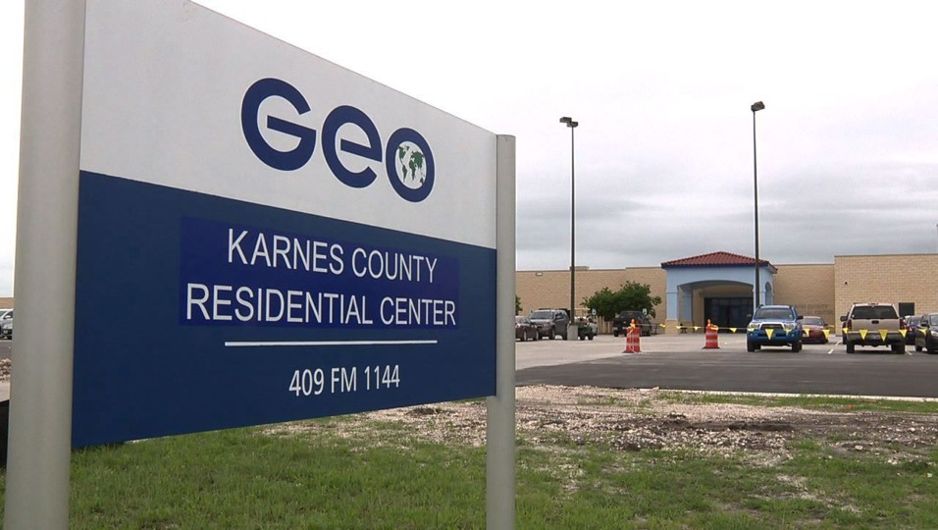

South Texas Family Residential Center, in Dilley is run by the Corrections Corporation of America (CCA), a for-profit prison company.

Who benefits?
• CCA earned $65.9 million in the second quarter of 2015, attributed to the opening of Dilley.
• GEO has invested $36 million in Karnes to increase capacity to 1,158 people in order to generate annual revenue of $20 million.
• Private prisons earn $100/day for a family of 3.
• Tremendous lobbying power leading to bed space mandate 34,000 beds must be available each year.

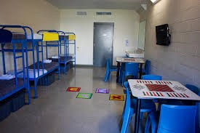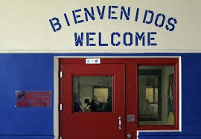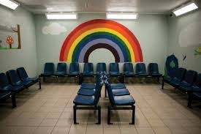
Karnes Decor

CONDITIONS OF DETENTION
• Substandard medical & dental care
• Sexual assaults
• Suicide attempts
• Poor food and undrinkable water
• Threats against parents
• Re-traumatization and PTSD
• Lack of adequate education
• Problems facing indigenous language speakers

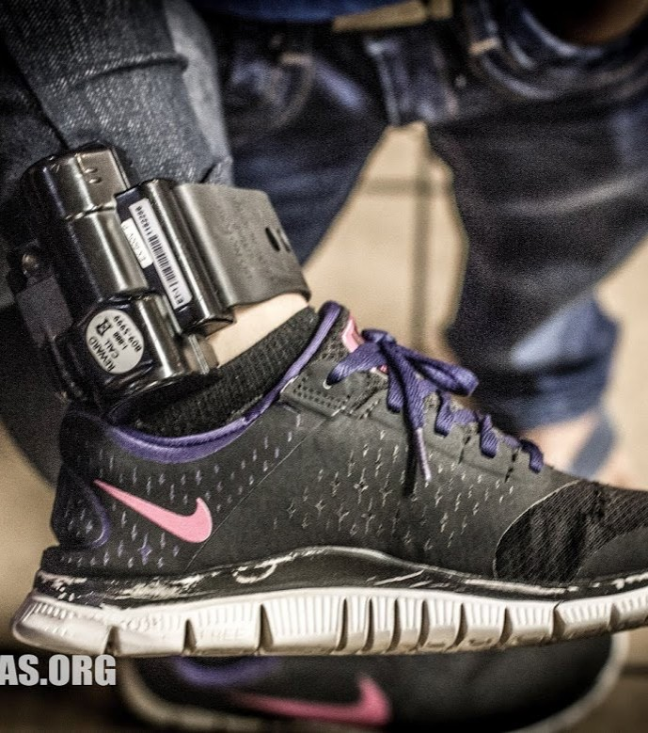
Protecting Children Flores v. Johnson

• 1997 Settlement Agreement protecting the rights of minors in immigration custody.
• Preference for “least restrictive alternative” (non-secure, licensed facilities).
• Release over detention except in cases of danger or extreme flight risk.
• Preference of release to a parent.
• Humane conditions of detention.

After the Flores Decision
• Mothers released on ankle monitors with their children, after passing the credible fear interview (or reasonable fear interview).

Profit Motive
• GEO purchased the company that manages alternatives to detention, including ankle monitor program

Asking for Asylum
at Karnes

● Expedited Removal → Removal
● Freedom from Detention
● Permission to begin formal asylum process (NTA)

The Path to
Asylum

Karnes Pro Bono Project
A project of RAICES (Refugee and Immigrant Center for Education and Legal Services) in San Antonio, TX

● Staff attorneys and legal assistants
● Volunteer attorneys, law students, and legal assistants
● support of San Antonio office staff

Ayuda Legal at Karnes

Intake
&
Preparation for Credible
--
Fear Interview Second meeting to draft written Declaration

+
& Representation at Immigration Judge Hearing
Release Charla

What We Do (Part One)

CFI Prep
• 20 minutes to 1 hour +
• prepare the client for an
oral interview
• familiarize her with format and what asylum officer is looking for
• ask her to tell her story
• advise her on content and presentation of her testimony

THE CREDIBLE FEAR
INTERVIEW

RIGHTS OF THE DETAINED WOMAN
● asylum interview conducted in her native language
● to request a female asylum officer
● to decide whether or not her
children stay in the room

Winning -- Getting a “Positiva”
To be successful in her CFI the woman must demonstrate:
● That she has suffered persecution, threats, or harm in her home country
● That her government is unwilling or unable to protect her
● That this persecution or harm can be
attributed to one of 5 protected grounds (the Nexus)

Protected Grounds

1.Race 2.Religion 3.Nationality 4.Political Opinion
5.Membership in a Particular Social
Group (PSG)

A Square Peg in a Round Hole

Most negative CFI’s result from a lack of NEXUS
rather than a lack of credibility
The majority of women at Karnes are fleeing domestic violence and violence, or threats of violence, at the hands of criminal gangs.

What We Do

Declarations
• 2 hours or more
• review transcript of negative CFI and identify problems
• discuss her story in greater detail; much closer focus on accuracy, chronology, cause and effect
• draft a first-person legal statement (3 or 4 pages) in English for the Immigration Judge
• read statement back to the client in Spanish and ask her to sign it

The Context of Narrative Production at Karnes
Fear and Trauma
○ experiences of violence and abuse in home countries
○ often harrowing journey north
Prison Environment
○ strict regulation of time and movement
○ constant surveillance
○ need to work with and around children
Legal Framework
○ high stakes
○ rigid narrative genres

Part Two:
Constructing the Narrative

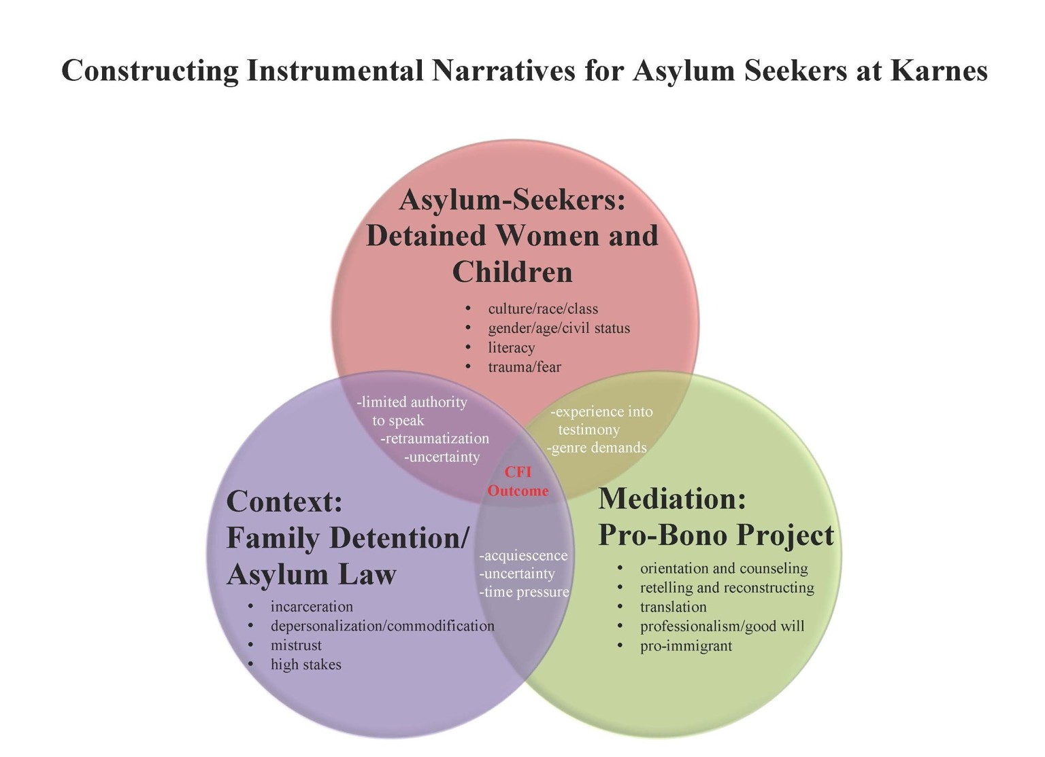

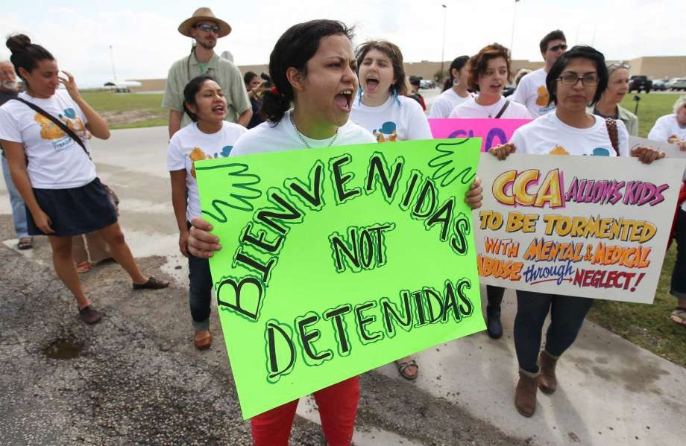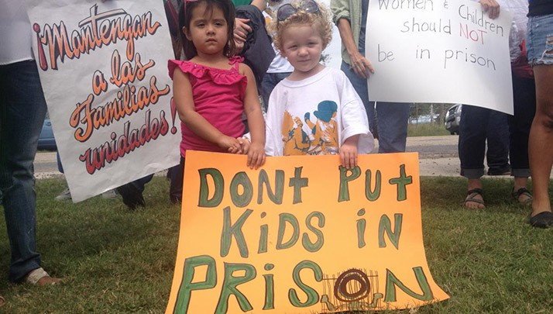

Credible Fears:
Central American Asylum Seekers in a Texas Detention Center
Emily Socolov <esocolov@gmail.com> Stephanie Aubry <aubry.9@osu.edu> Jessica Chapin <jchapin@swbell.net>
------------------
RAICES (Refugee and Immigrant Center for Education and Legal Services ) <https://www.raicestexas.org>
GEO GROUP <https://www.geogroup.com>

