Credible Fears:
Central American Asylum Seekers in a Texas Detention Center

Chair: Emily Socolov (University of Texas)
Stephanie Aubry (The Ohio State University)
Jessica Chapin (Independent Scholar)

Discussant: William Westerman (New Jersey City
University)

Sponsored by the Folklore Latino, Latinoamericano, y Caribeño Section and the Politics, Folklore, and Social Justice Section

Part One:
Orientation: Seeking Asylum
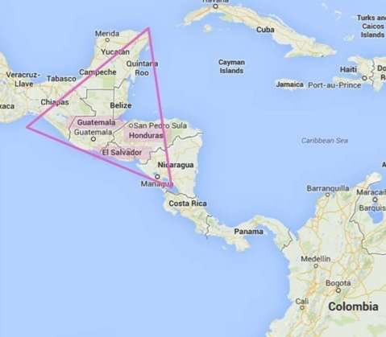
Asylum Seekers from the Northern Triangle: A Humanitarian Crisis

• El Salvador

• Honduras

• Guatemala

U.S. involvement in Central America During the Cold War
• Over $4 billion in economic and military aid from U.S. to El Salvador alone
• Soldiers trained at the School of the Americas in Ft.
Benning, GA
• Soldiers trained to be exceptionally efficient; trained to intimidate by committing brutal and debasing acts of violence
• Salvadoran military became a model for U.S. proxy wars abroad (Model became known as the “Salvador Option”)
Democratization in El Salvador (1992)
• Domestic security and national intelligence placed under civilian control
• Military’s officer corps purged
• Military’s doctrine re-written to stress the primacy of human rights
• Multiple political parties
• Free, fair, transparent elections
• Freedom of expression, freedom of association, freedom of the press

• To a degree, political authority in El Salvador has acquired more legitimacy since the Peace Accords

• But, regional homicide rates spiked in the Post-Cold War Era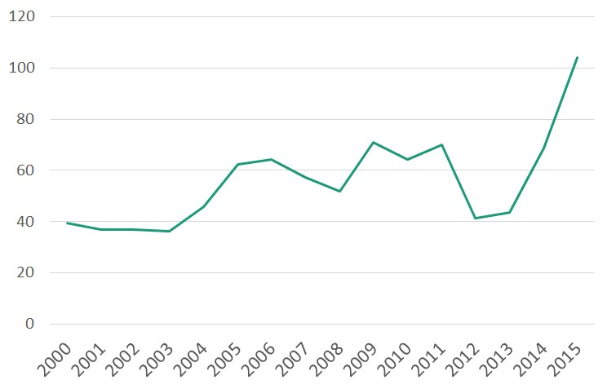

Number of homicides in El Salvador by Year per 100,000 Inhabitants
Data source: U.N. Office on Drugs and Crime
Homicide Statistics for Central America
Epidemic Level: 10 per 100,000 inhabitants
United States: 4 per 100,000
United Kingdom and France: 1 per 100,000

El Salvador Honduras
2014: 68.6 per 100,000 2014: 66 per 100,000
2015: 104 per 100,000 2015: 60 per 100,000
2016: 81.2 per 100,000 2016: 59.1 per 100,000

• Violence commonly attributed to gangs (maras)
• In 2015 El Salvador had the highest homicide rate in the world
• In 2012 Honduras had the highest homicide rate in the world

Given the successful political changes in the Post-Cold War Era, has Central America not experienced peace?
Simultaneous developments in El Salvador following Peace Accords (ca. 1992):
- . Security Gap: Rapid purge of military & police force; coercive forces cut from 60,000 to 6,000 in a matter of weeks.
- . Surge in deportations during Clinton administration:
  - ) Millions of Central Americans fled to U.S. during civil wars; many granted amnesty during Regan administration
  - ) (1992-2001) 32,1000 Salvadorans deported from U.S., many with criminal records (gang members)
- . Rapid liberalization of the economy – shift away from an agro- export economy
Result: Steep escalations in homicides in the region

Non-traditional

Maquila Remittances
Agrarian

0 10 20 30 40 50 60 70 80 90
2010 1978

Foreign Currency Inflow to El Salvador in %
1978: 81% of the foreign currency inflow into El Salvador came from agrarian exports 2004: 70% of foreign currency inflow came from remittances, and 5% from agrarian exports

Rapid economic transformation generated by CAFTA and other free trade agreements Central America transformed into Logistical Corridor to move goods through the region

Migration and El Salvador

• Migration within borders due to economic shift from agriculture to remittances (from rural to urban areas)
• Emigration has escalated since the civil war
• Currently over 2 million Salvadorans in the U.S. – almost 25% of the population
• $4.2 billion sent in remittances to El Salvador in 2013 (16.4% of GDP)

Reliance on high-risk, undocumented emigration to sustain Central American economies

Root Migration Causes
• World’s highest murder rates in Honduras and El Salvador
• Gang control, extortion, police corruption, lack of governmental protection. Mara Salvatrucha or MS-13 started in Los Angeles by Salvadorans in the 1980s in competition with Calle 18, initially Mexican but now in Central America
• Domestic violence and gender-based violence

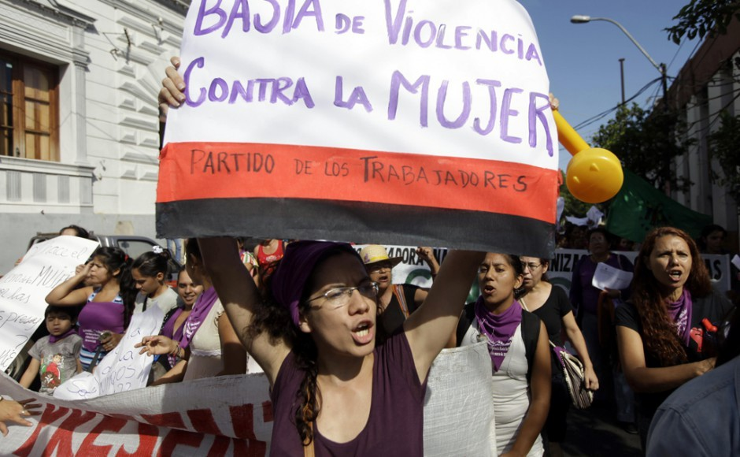

According to a 2011 study, El Salvador has the highest rate of femicide in the world. The rate tripled between 2000 and 2011 to over 600 reported cases.
Guatemala is third, and Honduras is sixth. These rates are on the rise.

Reported cases of domestic violence in El Salvador have increased four-fold between 2000 and 2009 to over 6,000 cases annually. Guatemala and Honduras have also experienced significant increases in the past decade.

Source: https://cgrs.uchastings.edu/our-work/central-america-femicides-and-gender-based-violence

Massive Deportations Back to the Region

Surge in deportations during Clinton administration:
- ) Millions of Central Americans fled to U.S. during civil wars; many granted amnesty during Reagan administration
- ) (1992-2001) 32,1000 Salvadorans deported from U.S., many with criminal records (gangs formed in L.A.)

Result: Steep escalations in homicides in the region

Absence of Domestic Security in Central
America in the Current Era
• Severe lack of resources for public security
• Over-dependence on private security (an unequal form of protection - only those who can afford it are protected)
• 2015: 21,500 police officers in El Salvador
• 2015: 23,546 registered private security guards, and 5,000 private security guards working without permits

Central American Children and Families who have fled to United States 2013-16

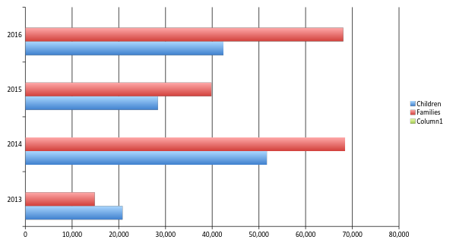

The Trek for Asylum
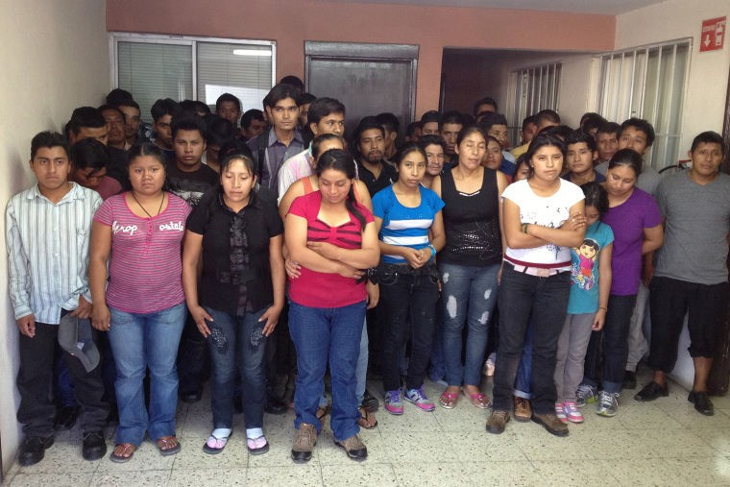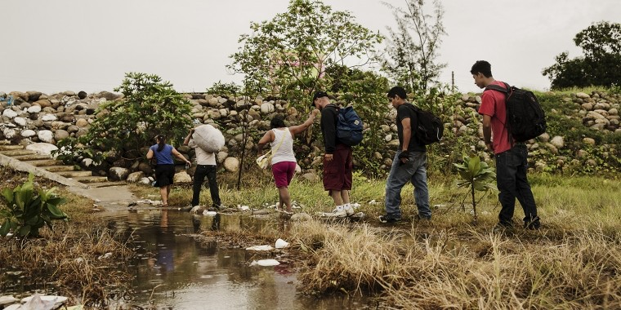

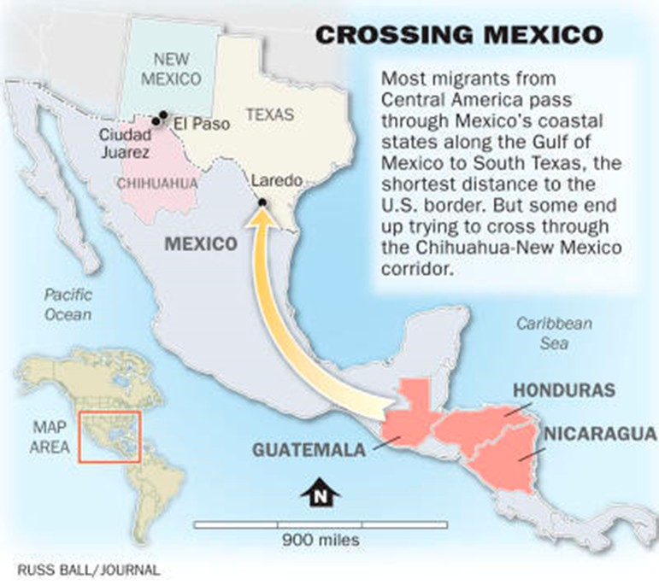
Journey through Mexico
• Network of coyotes/guides
• A combination of travel by bus, train, and on foot
• Business of moving people
• Connections with narcotraffickers

Image Credit: Albuquerque Journal

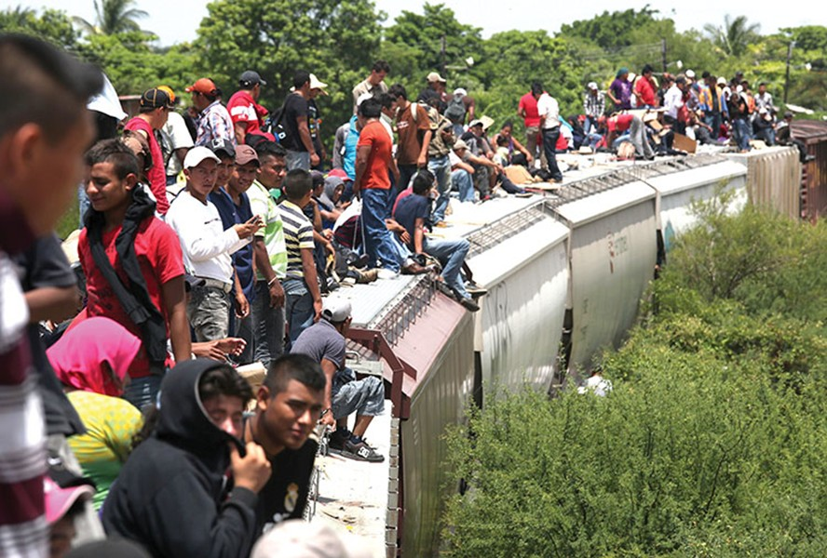

Image Credit: US Berkeley Center for Latin American Studies

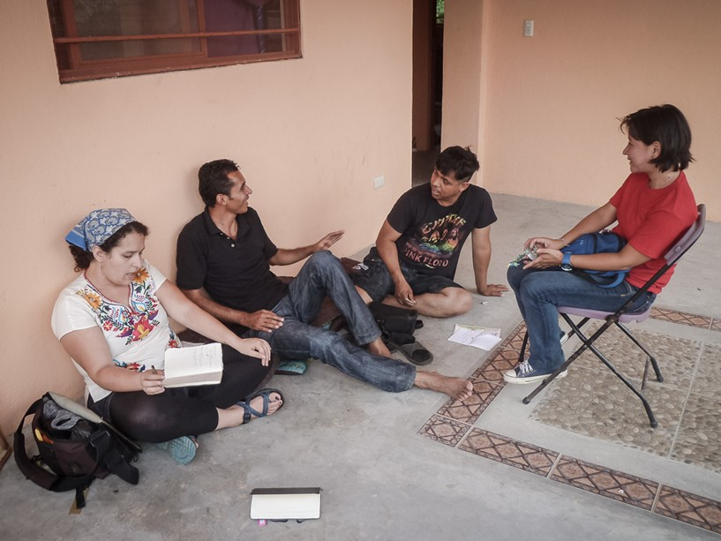
Image Credit: Hermanos en el Camino, which provides refuge and support for migrants in Oaxaca, Mexico

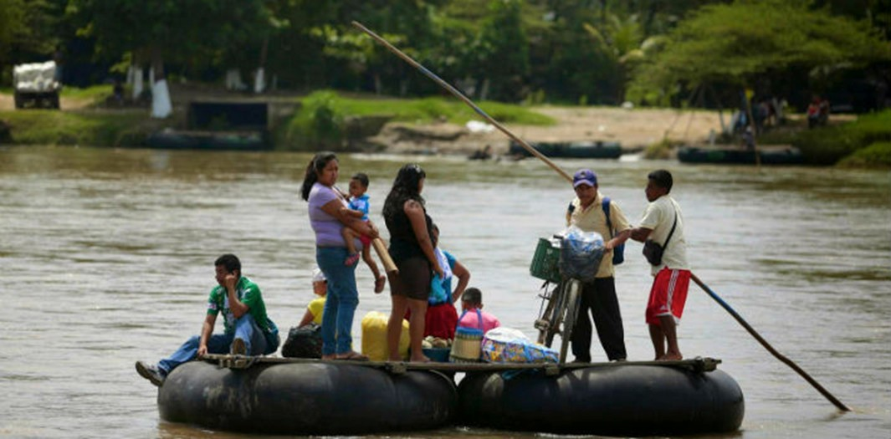

Crossing en balsa / Networks of intelligence / Rumor
Image credit: Diario Liberal del Sur

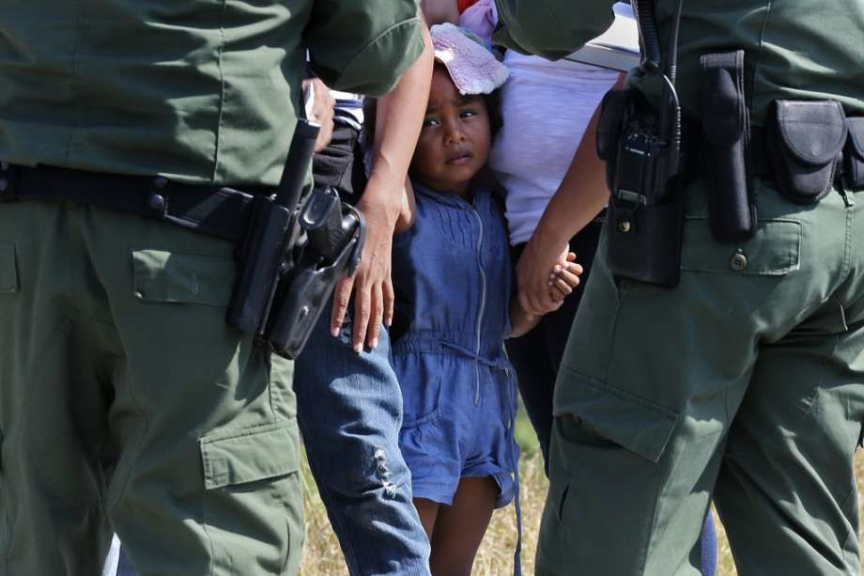
Border control, TX (Houston Chronicle)

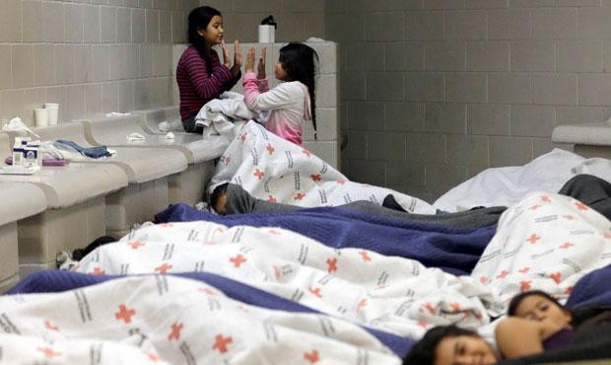
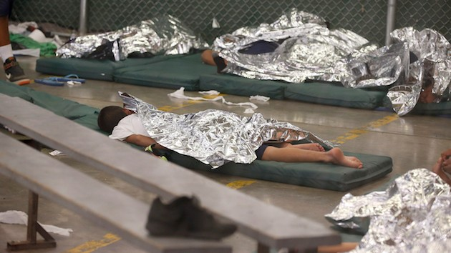
From Detention to Karnes

Heileras and Perreras

Family Detention: The U.S. Response to the Central American Refugee Crisis
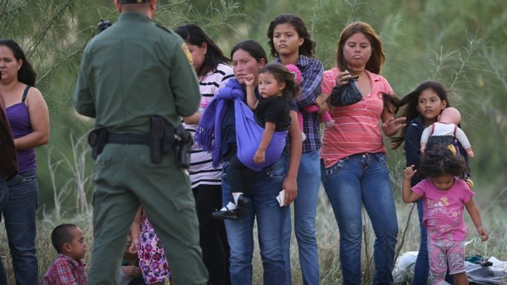

Why Family Detention?

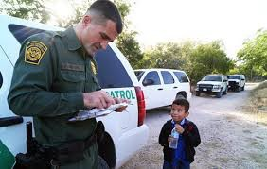
According to the US Government:
• All Central American migrants are economic migrants, with no valid asylum claims
• National security risk
• Deterrent strategy

But Aren’t Asylum Seekers Protected?

The United States is obliged to recognize valid claims for asylum under these statutes:

• 1951 UN High Commission on Refugees Convention and its 1967 Protocol. The signatories to these agreements were obliged not to return refugees to the place where they would face persecution.

• Refugee Act of 1980 by the United States Congress reiterated this agreement and established the Office of Refugee Resettlement (ORR) within the U.S. Department of Health and Human Services (HSS) to help refugees begin their lives in the U.S.

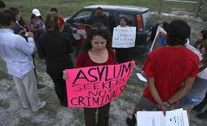

Despite their stated claims, asylum-seekers from Central America have been criminalized.

Expedited Removal as a Policy Choice:
Denying non-citizens entry to and/or causing physically removal from the United States without going through removal proceedings before a judge.

• Illegal Immigration Reform and Immigrant Responsibility Act of 1996, signed by Clinton. Initially implemented at specific ports of entry. Didn’t take full authority at first.
• Credible Fear screening process for asylum seekers instituted in 2002.
• Expansion to 100 miles border zone/ in the U.S. for 14 days. Bush signed in 2004 – full roll out by 2006.
• Re-implemented by Obama in June in 2014
• Trump promised to fully implement all aspects of 1996 act. Expedited removal of people who had been in country for less than two years.

ICE Family Detention Centers
Berks County Residential Center,
Leesport, PA – Mar 2001 – present
➢ capacity is 96 beds

T. Don Hutto- Taylor, Texas May 06-Aug 09
➢ Closed due to inhumane treatment of detainees, especially children

Artesia, New Mexico, June-Dec 2014
➢ Closed due to expansion of other facilities in other states

ICE Family Detention Centers -2

Karnes County Residential Center
Karnes City, Texas opened in Feb 2012, transitioned to a Family Residential Center in 2014 - to present
➢ capacity is 1158 mothers and children

South Texas Family Residential Center, Dilley, Texas Nov 2014 to present
➢ capacity is 2400 beds
ICE’s Total Family Detention Capacity is 3,300
Karnes County Residential Center
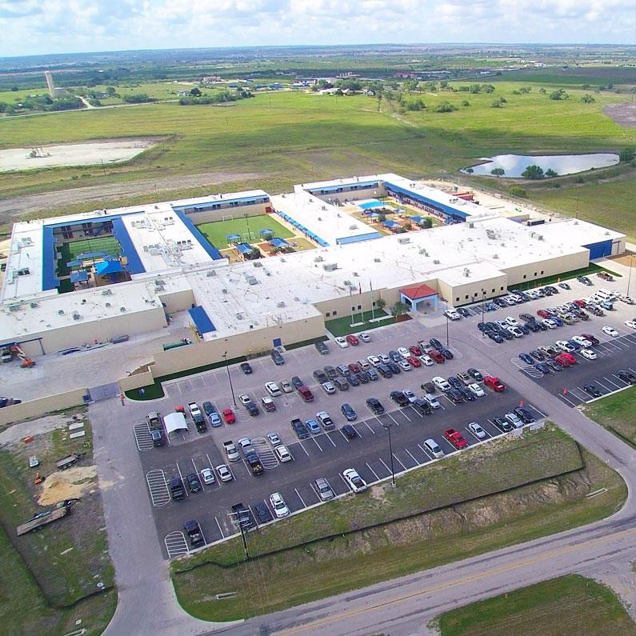

Population of Karnes City, Texas = 3,350 (2016)

